Planning Group Report – September 2024

Previously circulated consultation responses, agreed and submitted since last TPC meeting, for formal agreement:

Application Number | Address |  |  | Details | Consultation Expiry
23/01419/FUL | Dinsdale House Baldwins Lane Tysoe Near Leamington Spa Warwickshire CV35 0TX |  |  | Conversion of a disused coach house and stables into a dwelling house. | 16/08/2024
Description
The existing structure is constructed in Hornton stone with corrugated steel roof sheets over a former thatch. The South-West slope of the roof is approximately 50% covered with solar panels.
The main structure is divided roughly into three bays, two were formerly used as stables and the third as a garage. There is a small brick lean to on the South-East gable elevation, The first floor is used for storage. The existing North-East elevation (rear wall of the building) is situated right on the site boundary and contains six original openings, five windows (one a partially blocked door) and a gate. These are intended to be blocked up with reclaimed stonework.
The existing South-West elevation will be retained in most part, existing openings being formed into windows within timber boarding and a large ??? screen. The existing solar panels will be refitted together with 5 new roof lights. The new roof will be covered with a natural blue slate.
The proposal entails rebuilding the existing roof, partially due to the decay of the existing timbers and the need for additional strength within the structure. In addition, increased room heights would appear to raise the height of the building by approximately 500/600mm. This may involve additional stonework below wall plates and verges on the gables.
The proposed dwelling will provide a hall, cloakroom, kitchen, lounge, utility room and study/dining room on the ground floor, together with two bedrooms, bathroom and storage with a void above the lounge (which could be used as an additional bedroom in the future) on the first floor. The creation of a bedroom within this void may create an overlooking/privacy problem to the four cottages at the rear.
Access is to be gained via the present drive with a car parking/turning area beside the North-West gable.

Recommendation – Support, underTysoe NDP Housing Policy 1 which supports new housing developments within the BUAB, where they otherwise conform with other developmeent plan policies, and under Housing Policy 5 which particularly supports the development of 2 and 3 bedroom houses, subject to the following condtions

- Samples of stonework and of roof slates for approval
- Restriction of Permitted Development Rights (to safeguard against overlooking/privacy of neighbouring cottages to rear of site, by future alterations to the property.
- Highways conditions
- Retention of existing Horse Chestnut tree adjoining the South-East gable.
Note: The retention of the existing timber window/door frames on the North-East elevation and blocking in the openings behind them, would add greatly to the visual appearance/relationship of this elevation with the existing cottages behind the site.
The bargeboards on the gables, whilst at the moment hiding the old thatch will look odd (due to their depth) on a new structure and perhaps a more traditional detail is needed.

Make no representation. |  | Object |  | Date Decision made: August 2024 via text and ratified at 9.9.2024 meeting
Support the application. | X | No Objection |  | Who will represent the PC at committee?

Application Number | Address |  |  | Details | Consultation Expiry
24/01681/VARY and  24/01865/VLBC | Badgers Farm House, Badgers Lane Lower Tysoe Warwick CV35 0BY |  |  | Variation of condition 2 of planning permission 08/00042/FUL/ 08/00043/LBC dated 28 August 2008 to allow the design of the garage to be changed and addition of solar panels. Original description of development: Conversion of barn into one holiday cottage. Formation of new vehicular access and construct new garage for existing farmhouse. Reroof existing farmhouse. | 23/08/2024
Description: The proposed newly-redesigned garage measures approximately 6.8m wide by 9.6m deep by 5m high (floor area approximately 65m²), built in timber-clad concrete block walls with a dual-pitched slate roof, the front roof pitch being approximately 30 degrees and the rear approximately 20 degrees with 12 solar panels on it. The four corners of the building will have natural stone conical piers (not structural, purely as ornate novelty).
At the front of the garage there will be a single timber up-and-over garage door approximately 6m wide. The garage will house two motor cars, with a rear section used for PV energy storage, together with a WC and handbasin. There is an internal staircase to storage in the roofspace.
The four elevations of the proposed garage are architecturally inappropriate and inadequate for the setting within the curtilage of a Listed Building at the head of Badgers Lane, where the majority of buildings are of traditional design/type/shape/size/roof pitches etc.
The garage granted 16 years ago, as part of the orignial permission, measures approximately 6m square (floor area 36 m²) with a roof height of approximately 5m, erected in local stone, with a slate roof and two garage doors.
The Planning Group is somewhat puzzled about why the applicant has applied for a Variation on Condition Number 2 of the original permission which relates to the submission of further details of joinery/glazing which appears to be of no relevance to the current application. Why hasn’t the applicant submitted a new planning consent application as is normal procedure?
The site of the application, ie. the applicant’s land, should be edged in red, with other land in their ownership edged in blue. At the moment, the full extent of the site cannot be certified by Certificate of Ownership A. The proposed site plan, without the site being edged in red, is somewhat misleading as most of the plan and notation is on land belonging to next door, ie. not in the applicant’s ownership. The new plans and notation have many misleading comments, for example
a the ‘barn recently converted’ was converted over 16 years ago.
b) the ‘proposed conversion of a barn into one holiday cottage’ was converted into a dwelling 15 years ago. It has never been used as a holiday cottage.
c) the ‘new 1200mm high stone wall’ was built 15 years ago.
d) Badger Farmhouse being ‘re-roofed in blue slate’, will require listed building consent if it is correct.

Recommendation – Objection for the following planning reasons:
The Planning Group considers that the design of the proposed garage is of insufficient architectural quality/design by reason of it size, siting, shape, roof pitches, roof detailing and use of materials, and will thereby be detrimental to the amenities of the adjoining Listed Building (Badger’s Farmhouse) and the immediate buildings in the surrounding area, which are mainly of a traditional design/structure/type.

Make no representation. |  | Object | X | Date Decision made: August 2024 via text and ratified at 9.9.2024 meeting
Support the application. |  | No Objection |  | Who will represent the PC at committee?

Application Number | Address |  |  | Details | Consultation Expiry
24/01625/FUL | Westcote House Tysoe Road Radway Warwick CV35 0BS |  |  | Change of use to schooling and competition livery. | 30/08/2024
Description: This application is for the change of use of 2 hectares of land from private recreational and agricultural equestrian purposes (granted in November 2010 under application 10/01152/FUL) to commercial schooling and competition livery for third party owned horses.
The site comprises a hard-surfaced access driveway, turning and parking spaces for 7 cars and 3 horseboxes, a menage, American-barn style stable block, a hay/feed storage barn, horse-walker, all weather turn out spaces and grazing paddocks. The change of use excludes the main house (Westcote Farmhouse), garage and garden.
There will be no intensification of the number of horses kept on site and no additional buildings are proposed. The proposal would create two full-time jobs and one part-time. An increase of 22 two-way vehicle movements from staff and visitors is expected per week, with other vehicle movements (deliveries/vets/horse lorries taking horses to competition etc.) remaining similar as currently. The site is well screened from the road directly in front by hedging along the Tysoe road and hedging behind Westcote Farmhouse garden.
An equestrian business is acceptable development under AS.10, and supported where utilising existing buildings and structures, also under CS.22.

Recommendation – No objection, subject to conditions to protect the amenities of the area, as below:
- The original permission for equestrian use (Application 10/01152/FUL) did not include any external lighting for the manege. We ask that the whole site should be compliant with Tysoe NDP’s and Cotswold National Landscape’s Dark Skies Policies.
- The applicant has offered a condition to limit the site to full livery to prevent any additional vehicle trips associated with DIY livery. We request this condition is imposed.
- There are open views of the site from the road in winter when approaching from the Tysoe direction, and from the Battlefields Trail, which runs along the North-Eastern boundary of the site (along public foottpath 287/SS21/1). There could be a demand to store extra horse boxes/lorries/trailers belonging to customers on site. To protect these views. as parking areas are not specifically marked on the submitted plans, there will be no onsite storage or parking up of customer horseboxes/lorries/trailers without further approval of the district planning authority.
Make no representation. |  | Object |  | Date Decision made: 9.9.2024 meeting
Support the application. |  | No Objection | X Subject to conditions | Who will represent the PC at committee?

Tree Consultations
Application Number | Address | Details | Consultation Expiry
24/01800/TREE | Tysoe Manor Shipston Road Upper Tysoe Warwick CV35 0TR | -T1 poplar - Fell. -T2 - T6 ash - Fell. -T7 Prunus - Fell. -T8 walnut - Fell. -T9 -T12 larch - Fell. -G1, scrub between T1 - T7 - Prune back from highway. -G2, areas containing dead pine and sycamore (yellow on map) - Fell. | 09/08/2024
Recommendation – Support
We strongly support this application. The hedge and trees project into the roadway, forcing vehicles heading towards the village over the centre line and badly reducing visibility. Pedestrians walking out of Tysoe on the Shipston Road or Poolgate footpaths must cross the road at this point or walk in the road. The bend already makes this difficult but the overgrowth is now making crossing dangerous. The dead and dying trees are of great concern to those in neighbouring properties and the work needs carrying out as a matter of urgency.

Current Consultations

Application Number | Address |  |  | Details | Consultation Expiry
24/01856/FUL | Tysoe Village Hall Main Street Tysoe |  |  | Installation of 45 photovoltaic panels and associated supporting metalwork, upon the southwest facing village hall roof. | 19/09/2024
Description: The Village Hall is within the Middle Tysoe Conservation Area. It was built in 1929 and re-roofed in 1992 with British Steel Profiles Long R ib 1000R sheeting in Goosewing Grey. This application is for the installation of a grid of 45 low-profile black or dark-grey photovoltaic panels, 15 wide by 3 high, measuring approximately 17m wide by 5.3m high, onto the southwest facing roof of the village hall which is 25m wide by 7m high, attached by associated metal bracketry. All other photovoltaic components, such as the battery and inverter, will be inside the building, with cabling discretely run and hidden where possible.
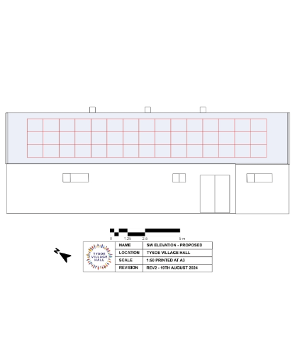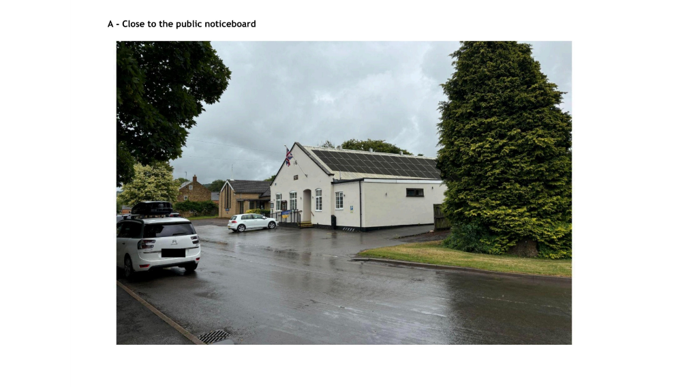

Recommendation – Support for the following planing reasons
Tysoe Village Hall is a Community Asset and under Tysoe NDP’s Community Assets Policy 1, proposals which enhance and improve existing community facilities will be supported. As for so many village halls nationally, the managing charity is struggling to keep up with enormous increases in energy costs, in spite of other energy saving measures having already been put in place. The building is not suitable for other forms of low carbon heating. This proposal will reduce the asset’s carbon footprint, reduce costs to help secure the halls’s long term future and help provide the warm and welcoming atmosphere that is so vital in supporting the community in a remote village like Tysoe. Therefore the proposal is consistent with CS.2, CS.3 and CS.25

Although the hall is in the Middle Tysoe Conservation Area and visible from the Cotwold National Landscape, it is only visible at close quarters from a short curved section of Main Street. In this specific location, and on this already utilitarian roof, it is felt PV panels will have limited visual impact on the street scene or views from the Cotswold National Landscape and the proposal will not result in any harm significant enough to outweigh the local and national public benefits of the scheme. Therefore we believe the proposal is consistent with CS.5, CS.8, CS.11 and so also CS.1.
As discussed in the application, we request panels with slim wires are selected, for as low a visual impact as possible.

Make no representation. |  | Object |  | Date Decision made 9.9.2024
Support the application. | X | No Objection |  | Who will represent the PC at committee?

Application Number | Address |  |  | Details | Consultation Expiry
24/02003/FUL and  24/02004/LBC | Tysoe Manor Shipston Road Upper Tysoe Warwick CV35 0TR |  |  | Conversion and extension of barns to form wellness centre with accommodation and creation of parking area. | 20/09/2024
Description: The site is within the Middle and Upper Tysoe Conservation area and the buildings are curtilage listed, being within the grounds of Grade II* Tysoe Manor. Previous planing applications have been granted to convert the barns into a dwelling and demolish some outbuildings, but works were not completed so the buildings survive.
The existing barns and stables form two L shaped wings around a central courtyard and consist of a series of various agricultural outbuildings – stables, barn, tack room, cattle shelter, granary, former dairy, pigsty and farm storage. The buildings are mainly of natural stone and brick with predominantly slate roofing. The new layout uses the existing form of the buildings, with alterations kept to a minimum. The pigsty will be increased in height and footprint, a new plant room will be added in matchng materials, and a new entrance canopy with a pitched, natural slate roof will join the two L-shaped wings.

The new ground floor layout will include 7 bedrooms (each with a connecting bathroom), yoga room, gym, kitchen, informal dining area, dining and lounge area, TV lounge, disabled toilet,staff accommodation, with various utility areas for storage/laundry/boots. The parts of the development which have a first floor will include 2 further bedrooms, each with own bathroom, and an upstairs study.

Materials used throughout will match existing. In places some materials will be improved (eg felt roofing replaced with lead)

Visitors will enter by an existing field gate to the east of the buildings which will lead to a new 16 place gravelled car park with timber edging. Some existing mature trees will help screen the parked vehicles, with additional tree planting proposed. The main entrance to Tysoe Manor is to be used for deliveries and maintenance access. A wildflower meadow adjacent to the car park is to be planted for Biodiversity Net Gain.

Recommendation - Support for the following planning reasons:
Although the buildings are mostly in reasonable condition, they are now redundant for modern farming purposes and are in danger of falling futher into disrepair without a viable use. We support this proposal under Tysoe NDP Built Environment Policy 1 where proposals, including changes of use, which enable the appropriate and sensitive restoration of listed buildings, will be supported, also under AS.10.
The intended small-scale business use will secure the long term future of the heritage asset, whilst also providing facilities and increase local employment opportunities, so is supported by Tysoe NDP Employment Strategic Objective 7.1 and CS.22.
The retention of the farm courtyard layout and the minimal structural changes will retain the farmyard appearance, so the scheme as a whole is senstitve to the historic setting. The thoughtful retention of most original openings, features, subdivisions and spaces, and proposed use of matching materials, makes the proposal consistent with Tysoe’s Built Environment Policy 2, CS.5, CS.8, CS.9 and CS.24.

Therefore the planning group recommends supporting the proposal, subject to conditions to protect the amenites of the area as follows:
1) A condition to restrict the use of the site to that of a ‘Wellness Centre‘ with accomodation and creation of parking area, as decribed in the application and the supplementary documents.
2) A condition to limit the use of the Eastern part of the site to car parking and landscaping, with adjacent wildflower meadoow, as shown in the application. There are to be new no built structures within the former paddock area along the frontage to the Shipston Road, without further specific planning permissions.
3) A condition requiring a landscaping scheme to sceen the car parking area, together with details of car parking surface, ground level and surface drainage.
4) A condition limiting the exterior/illumination on site to conform with Tysoe’s Dark Skies policy .
5) Highway conditions as per Warwickshire County Counil requirements.
6) A condition requiring samples of materials to be submitted to the LPA for further approval ie. new materials and re-used materials to be used in repairing existing wall, rooves etc.
7) A condition requiring that all on-site advertisements shall be submitted to the LPA for approval.

Make no representation. |  | Object |  | Date Decision made: 9.9.2024
Support the application. | X | No Objection |  | Who will represent the PC at committee?

Decisions Issued Since Last Tysoe Parish Council Meeting
Application Number | Address | Details | Tysoe Parish Council Comments | Target date for Decision | Decision Date | Decision
24/01472/TREE | Elm Cottage The Green Tysoe Warwick CV35 0SN | T1 - leylandii and hedge - Remove | No Objection | 25/07/2024 | 24/07/2024 | Tree Consent with Conditions
24/01800/TREE | Tysoe Manor Shipston Road Upper Tysoe Warwick CV35 0TR | -T1 poplar - Fell. -T2 - T6 ash - Fell. -T7 Prunus - Fell. -T8 walnut - Fell. -T9 -T12 larch - Fell. -G1, scrub between T1 - T7 - Prune back from highway. -G2, areas containing dead pine and sycamore (yellow on map) - Fell. | Support | 19/08/2024 | 13/08/2024 | Tree Consent with Conditions

Previous Consultations, still Pending Consideration
Application Number | Address | Details | Target date for decision
24/01225/FUL and  24/01226/LBC | Tysoe C Of E Primary School School Lane Tysoe Warwick CV35 0SD | Removal and rebuild of the existing gable wall down to eaves level, including provision of 6 wall plates and steel rods. Replacement of pitched roof tiles, rooflights, fascias and rainwater goods and other associated works | 06/08/2024  Revised to 07/10/2024
24/01205/FUL and  24/01206/LBC | Tysoe C Of E Primary School School Lane Tysoe Warwickshire CV35 0SD | Proposed replacement aluminium windows and doors, featuring laminated inner glazing and toughened outer glazing, some windows will have an insulated top panel and stonework surrounds will be repaired as needed. | 09/07/2024  Revised to 07/10/2024
24/00009/FUL | Applecross Fields Located On Tysoe Road 150M North West Of King Johns Lane Radway | Change of use of land to children's forest school, including associated access track, car parking area and ancillary structures such as toilet block (retrospective) | 18/07/2024  Revised to 07/10/2024
24/00345/FUL | The Cottage Peacock Lane Tysoe Warwickshire CV35 0SG | Erection of detached garage with home office over and formation of new vehicular access  Listed Building Consent | 09/04/2024  Revised to 08/05/2024
22/02935/FUL | Land Adjacent to Hardwick Gorse Tysoe Road Kineton Warwick | Construction of anaerobic digestion facility, comprising silage clamps, digestor tanks, lagoons, administrative buildings, landscaping and access. | 03/01/2023

Appeals in Progress
Application Number | Address | Details | Tysoe Parish Council Comments | SDC Decision | Appeal Start Date | Appeal Decision Date | Appeal Decision
23/03179/FUL | Winchcombe Farm Shenington Road Upper Tysoe Warwickshire CV35 0TH | Change of use of two buildings from residential holiday let usage to residential usage ancillary to the main building. No changes to internal or external layout or appearance | Objection | Refusal | 18/06/2024

