Planning Committee Report – June 2024
Current Consultations
Application Number | Address |  |  | Details | Consultation Expiry
24/01219/AGNOT | Mill Farm Tysoe Road Oxhill |  |  | Replacement of existing dilapidated agricultural building with new agricultural building. | 10/06/2024
Description New multipurpose open-fronted agricultural building to replace an existing dilapidated building adjacent to a clustor of existing farm buildings. It will meet a specific need to house ewes and lambs in lambing season, and for use as an isolation shed. Constructed of steel frame with fibre cement roof sheets, concrete panel sides with and timber space board cladding and sheeted metal gates.
Dimensions: Length 13.71m, width 7.44m, height 4.73m to ridge, Area 102m².
Recommendation – No objection
Make no representation. |  | Object |  | Date Decision made
Support the application. |  | No Objection |  | Who will represent the PC at committee?

Application Number | Address |  |  | Details |  |  | Consultation Expiry
24/01205/FUL and  24/01206/LBC | Tysoe C Of E Primary School School Lane Tysoe Warwickshire CV35 0SD |  |  | Proposed replacement aluminium windows and doors, featuring laminated inner glazing and toughened outer glazing, some windows will have an insulated top panel and stonework surrounds will be repaired as needed. |  |  | 24/06/2024
Description The school building is Grade II listed and within the Conservation Area. The current windows and doors are single glazed, in a poor state of repair, provide poor thermal insulation and in some cases are dangerous. All 35 windows will be replaced with white SMART systems Heritage units to match current openings, featuring laminated inner glazing and toughened outer glazing, finished with PPC aluminum. Where some windows have gothic arches, a rectangular unit will be placed in the lower portion or the window with an insulated panel in the arch area at the top. All 11 external doors will be replaced with SMART systems smart wall doors, with powder coated aluminium double glazed units featuring ‘E’ glass for better heat retention.
Stonework surrounds will be repaired as needed.
Recommendation – No objection
The replacements will provide safe and far more thermally efficient windows as befits a modern education setting. They will allow comfortable teaching temperatures to be maintained and save energy. We would have preferred a more sympathetic detail for the infill of the gothic arches. The colour is to be white to replace original, however a more subtle colour, such a soft grey, may be more attractive and help to reduce contrast between the frame and thermal panels, drawing less attention to them.
Make no representation. |  | Object |  | Date Decision made
Support the pplication. |  | No Objection |  | Who will represent the PC at committee?
Application Number |  | Address |  |  | Details | Consultation Expiry
24/00009/FUL |  | Applecross Fields Located On Tysoe Road 150M North West Of King Johns Lane Radway |  |  | Change of use of land to children's forest school, including associated access track, car parking area and ancillary structures such as toilet block (retrospective) | 20/06/2024
Description Change of use of a field from agricultural use (currently also used as a certified campsite) to Class F2 ‘Local Community’ use as a children’s forest school for up to 20 children and their carers, typically for a 2 hour session. Hours of use 10am-2pm weekdays and 10am-1pm weekends including bank holidays. Open from February to December. A public footpath runs through one corner of the wood.
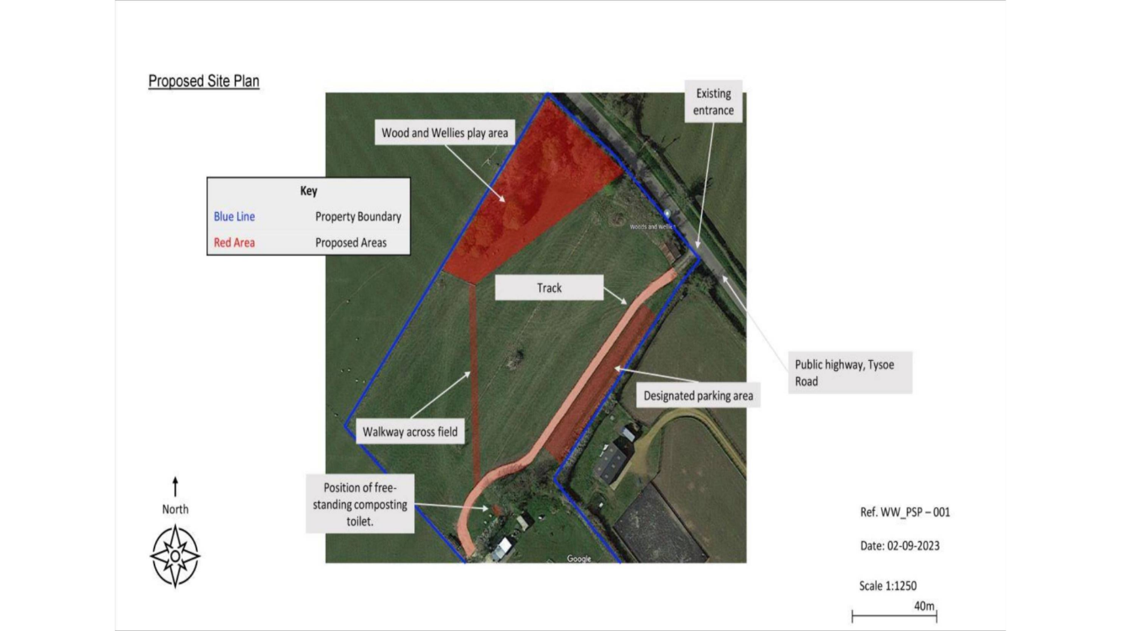

Recommendation – Objection for the following planning reasons
We recognise the great value of activities which encourage young children to learn in nature and the part time employment this proposal creates (0.76 FTE). However, balanced against this, we believe that this proposal causes the following harms due to its location:

Unsustainable Location: The site is not easily accessible by most residents of Tysoe or Radway (especially those with young children) except by car, and not easily accessed by public transport. The remote location is unsustainable and means it will be unlikely to support other rural services, (Contra CS.1, inconsistent with CS.24)

Impact on the Character of the Local Area:
The site is relatively open, and in an area known for its scenic views. The open car park for 20 cars would be visible in views to and from the Cotswold National Landscape so would not maintain and enhance the scarp and foot landscape. The rural tranquillity of users of public footpaths with views of the site, especially the one running through the site, would be affected. The cumulative effect of this change of use, with the existing campsite and nearby dog-walking field recently granted permission (Application Number 23/01737/FUL), could lead to loss of rural character for this area Contra CS.5, CS.7, CS.9, CS.11, CS.24 and Tysoe NDP Policy 5.2, 5.3, para 4.4.01).

Potential to Harm to Wildlife.
There is no Ecology Statement and the impact of up to 20 children and their carers, 3-4 hours a day, 7 days a week, could lead to damage from overuse in the relatively small copse, resulting in loss of biodiversity, contra CS.6. If SDC are minded to grant this application, we would request that a Woodland Management Plan is required to protect the biodiversity of the site, as the area is known to be rich in wildlife such as Great Crested Newts and many species of bats. Also, conditions to limit opening hours and number of users appropriately.

Highways Safety
If up to 20 vehicles are to enter and exit the site at the same time, cars may have to wait on the road which could cause obstruction.

We have some additional concerns about safety if the site is to be continued for use as a campsite and if the toilet is shared with the campsite. Also, if dogs continue to be allowed loose on the campsite. The public footpath through the forest school could also cause safeguarding issues.

Alternative Provision in the Parish
Many of the benefits of the proposal are already being provided elsewhere in the parish. Tysoe Pre-School runs regular Forest School sessions, with a fully trained Forest School leader, within walking distance of the pre-school in the centre of Tysoe. There is also a weekly stay and play session at Tysoe Primary School and monthly session at St Marys’ Church, for parents and carers to meet and support each other. Both Tysoe and Radway have popular children’s play parks. There is no identified need for another such facility in Tysoe NDP, and this is evidenced by the letters of support, the majority of which come from those outside the Parish.

On balance, we feel that though the proposal has many benefits, most are already being delivered elsewhere in the parish, and they do not outweigh the harms that would be caused by using this unsustainable, tranquil, rural location. The change of use of this 3.4 acre field to F2 Community Use would not maintain and enhance the rural character of the area and so is not consistent with AS.10, or Tysoe NDP, which aim to protect the countryside for its intrinsic value.
Make no representation. |  |  | Object |  | Date Decision made
Support the application. |  |  | No Objection |  | Who will represent the PC at committee?

Current Tree Consultations
Application Number | Address | Details | Consultation Expiry
24/01060/TREE | St Marys Church Main Street Middle Tysoe Tysoe Warwickshire CV35 0SH | T1 redwood - Reduce by 5 metres. -T2 and T3 Scots pine - Remove deadwood. -T4 ivy limb - Fell to ground level to clear neighbouring property. -T5 and T6 yew - Reduce by 1m and trim to clear neighbouring property. | 05/06/2024
Recommendation – No Objection

Decisions Issued Since Last Tysoe Parish Council Meeting
Application Number | Address | Details | Tysoe Parish Council Comments | Target date for Decision | Decision Date | Decision
24/00853/TREE | Tawny Cottage Main Street Middle Tysoe Tysoe Warwickshire CV35 0SW | T1 skinny silver birch - Fell. -T2 cherry - Fell. -T3 willow - Fell. -T4 lime - Fell, as growing up through Maple tree (T5). -T5 maple - Lift lower canopy to 3 metres and thin. | No Objection | 29/05/2024 | 09/05/2024 | Tree Application not required
24/00795/VARY | Byeways Main Street Middle Tysoe Tysoe Warwickshire CV35 0SW | Application Reference Number: 24/00219/FUL Date of Decision: 26/03/2024 Condition Number(s): 2, Conditions(s) Removal: To make amendments to the roof structure to comply with building regulations and make it a usable space.The development hereby approved shall be carried out in accordance with the attached plans and drawings. | No Objection | 29/05/2024 | 29/05/2024 | Variation Permitted, with Conditions
24/00896/LDP | 13 Avon Avenue Tysoe Warwickshire CV35 0SP | Building extra rooms to include home office and gym to previously approved garage. | N/A | 05/06/2024 | 05/06/2024 | Lawful Development Permitted

Previous Consultations, still Pending Consideration
Application Number | Address | Details | Target date for decision
24/00917/LBC | Cornerways Shipston Road Upper Tysoe Warwick CV35 0TR | Replace existing door and window for hardwood bi-fold doors to rear flat roof extension | 18/06/2024
24/00345/FUL | The Cottage Peacock Lane Tysoe Warwickshire CV35 0SG | Erection of detached garage with home office over and formation of new vehicular access  Listed Building Consent | 09/04/2024
23/03194/FUL | Woodside House  Banbury Road  Sunrising Hill  Tysoe Warwickshire OX15 6HR | Alterations and extensions to dwelling, engineering works for creation of swimming pool, link to and erection of outbuilding providing garaging, ancillary accommodation including annex and stables (comprising 3 x stables, tack room, wash down area and feed/hay store), change of use of land to equestrian (private use), access track, and all associated works | 27/02/2024/Revised to 08/05/2024
22/02935/FUL | Land Adjacent to Hardwick Gorse Tysoe Road Kineton Warwick | Construction of anaerobic digestion facility, comprising silage clamps, digestor tanks, lagoons, administrative buildings, landscaping and access. | 03/01/2023

