Tysoe Recreation Ground Report

The rear hedge of the play park has been cut back. Request we get quotes to cut the side hedge.

Water in the drainage ditch is flowing well after recent floods but a lot of brash/debris has gathered around the opening to the culvert at The Sinks. Request we obtain a quote to clear to prevent future blockage

. 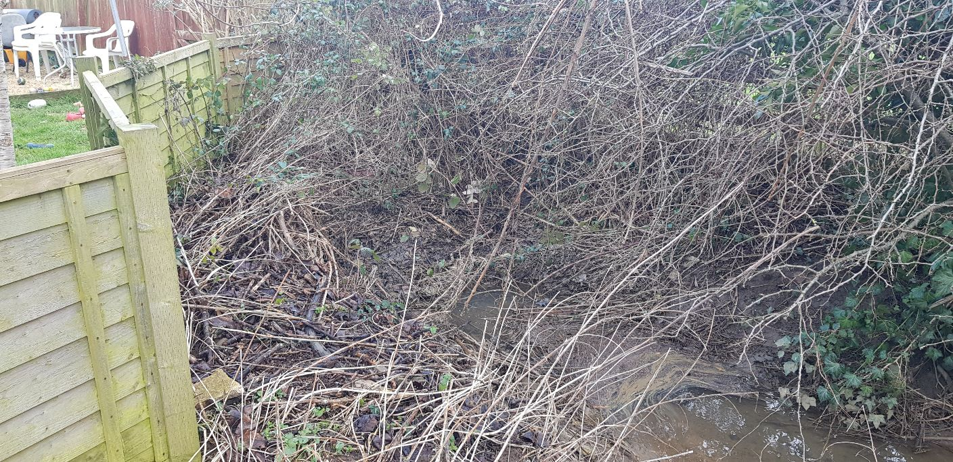
Sandbags have had to be used to prevent surface water going into a house at Avon Way. What can be done to prevent this happening in future? French drain/drainage ditch/Flood Defence System?
Tasks Arising from RoSPA Safety Inspection Report on 11th October 2024, in order of highest risk score for each item, updated for progress.
Item | Task | Risk Score | Risk Level | Contact | Date Task Completed
Cableway | Chain links notched - Replace the worn parts  It is considered that the runway will have insufficient ground clearance under seat.- No Tasks for this Finding (Why not?)  Bolt(s) loose - tighten | 9  8  4 | Medium  Medium  Low | Kompan  Kompan – will realign seat  Kompan | Engineers booked
Swing - Junior | Loose fill levels are too low to provide adequate protection - Rake and fork over and top up as required to maintain minimum depth  (400 mm).  Some chain wear. Monitor for further deterioration and replace before 40% wear. | 9  4 | Medium  Low | AV Rake  AV/CB | New bark added Nov 2024  Ongoing raking required  Ongoing monitoring
Picnic Tables - | Must remain outside the minimum space of the permanently installed items - Monitor and control the placement of portable items. | 6 | Medium | AV/CB  Advise Thomas Fox | Ongoing monitoring
Multiplay - Large | Replace missing grab handle  Timber is decayed. Replace affected parts.  Screws are missing on third from bottom piece of wool on climbing wall. Replace. | 6  6  6 | Low  Low  Low | AV/CB to fit new handle  Gareth Attwell  AV/CB | Fitted Oct 2024
Rocker – See - Saw | Delamination of wood. Repair. | 6 | Low | Gareth Attwell
Gate | Adjust gate / posts / fit new rubber buffer to ensure a spacing of at least 12 mm throughout the range of the gate to remove the entrapment. The 12 mm gap also should apply on the hinge side of the gate. | 6 | Low | CB to fit concertina buffer.
Tractor and Carriage | Edges not radiused or chamfered. Provide a 3 mm radius or 3 mm  chamfer.  Timber is decayed. Check on a routine basis. Repair | 6  3 | Low  Very Low | Gareth Attwell
Swing – Basket | Chain link connectors notched. Replace | 4 | Low | KOMPAN | Engineers booked
Edging Around Bark Areas | Check on a routine basis. Replace affected parts. | 4 | Low | Gareth Attwell | All replaced December 2024
Rocker – 4 Seat | The spring is rusty. These have been known to fail without warning, leading to a collapse of the unit. Monitor. | 3 | Very Low | AV/CB
Agility Trail | Cap missing - Replace.  Bolt(s) loose - Tighten.  Timber is splintered - Repair. | 3  3  3 | Very Low  Very Low  Very Low | Creative Play UK Ltd  Gareth Attwell  Gareth Attwell
Rotator Bowl | Surface is uneven. Make good. | 3 | Very Low | Gareth Attwell

Request we ask Gareth Attwell to quote for the following outstanding jobs:
Item | Task | Risk Score | Risk Level | Contact | Date Task Completed
Multiplay - Large | Timber is decayed. Replace affected parts. | 6 | Low | Gareth Attwell
Rocker – See - Saw | Delamination of wood. Repair. | 6 | Low | Gareth Attwell
Tractor and Carriage | Edges not radiused or chamfered. Provide a 3 mm radius or 3 mm  chamfer.  Timber is decayed. Check on a routine basis. Repair | 6  3 | Low  Very Low | Gareth Attwell
Agility Trail | Bolt(s) loose - Tighten.  Timber is splintered - Repair. | 3  3 | Very Low  Very Low | Gareth Attwell  Gareth Attwell
Rotator Bowl | Surface is uneven. Make good. | 3 | Very Low | Gareth Attwell

Amanda Venables 10/01/25

