

The Tysoe & District Record

The first Record was issued in 1951 devoted to recording events that happen in our village. The Record’s editor attended the last Village Assembly. There have been another 9 issues of the village newsletter since then. The latest, issue number 847 for June/ July 2024, has just been published.
This report will focus on changes that have happened since the last Assembly.

Changes to the Record Team
The editor, editorial assistant, distribution coordinator and treasurer/subscriptions officers – namely Shirley, Helen, Jude and Carol have all stayed the same, but we have welcomed a new advertising officer- Ben Viollet who has taken over from Matthew Harcourt. In addition, we have created a new role – that of a social media officer which Emma Tompkins is ably filling for us. Not forgetting our all-important distributors (all 15 of them) who deliver the copies of the Record, all year round, in all weathers!

With our energized and even bigger team, the Record is set fair for the future. I would emphasise that all these roles are voluntary, so we are especially grateful for the dedication and commitment shown by the entire team.

Finances

We pegged the annual subscription at £5 per annum (from April through to March) again this year. More subscribers are choosing to pay online, which works well providing Carol, our treasurer, can match the payments to our database! The Records’ production costs are covered by the combined income from subscriptions and advertising. We currently print 415 copies. Each copy costs us c.90p to print. We are currently experimenting with selling additional copies in Tysoe Village Stores and the Tysoe Post Office for £1 each.

Record Recruitment Drive
We decided to run a mini recruitment drive earlier in the year to:
- Give lapsed subscribers the opportunity to reconnect
- Encourage new subscribers to come on board
To raise our profile, we put posters on the village notice boards, ran ads in the Record and posted on the Tysoe Record and Village Notice Board Facebook pages.
Result: we had 15 new recruits from the start of the year, most of them newcomers to Tysoe; but given that there is always a churn factor with people moving away, etc – the total number of our subscribers is still just over 400.

Demographics – Our Readership
While we are aware that our core readership tends to be older, we do try to engage with younger members of the community i.e. parents of young children and even the children themselves by running stories they have written as in our special Book Club issue in March 2024.

We do endeavour to provide something for everyone i.e. the history of Tysoe and images of old Tysoe seem to be very popular, but at the same time we try to cover local events, projects and happenings – even less savoury ones like Tysoe sewage works upgrade as featured in the latest issue. We are very grateful for our contributors like Rosemary Collier, Phil Walker, David Freke and Mike Sanderson to name just a few, who provide us with such excellent content. We also make a point of including regular reports from Charmaine Swift, our Parish Clerk, for the Tysoe Parish Council.

Covering Village Events



The Record editorial aims to give proper coverage to village events i.e. Tysoe Flower Show. We went to town last year with our pre and post Flower Show coverage.


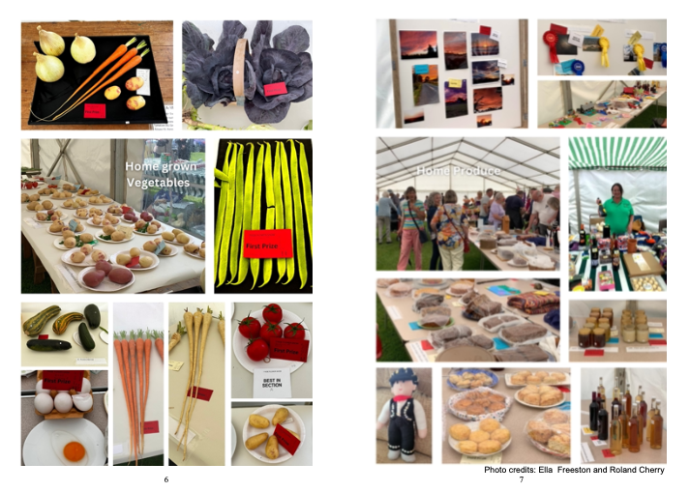

Other significant events, like Laura’s Annual Tractor Run featured in the latest issue, have also been accorded a whole page photo montage.


Special Editions
As part of our commitment to support Tysoe’s community, we go the extra mile and produce Special Editions. Our most recent one was the Christmas Stories Supplement which was issued and distributed to all our subscribers with the December / January issue.

Welcome Pack
The Record, together with Tysoe Parish Council, distributes a Welcome Pack to all newcomers to the village. This includes a copy of the most recent Record, a cover letter from the Editor and a letter with useful contact details and telephone numbers from the Parish Council. Various clubs and societies also include flyers i.e. a Tysoe Wildlife Map, Tennis Club, Community Orchard, etc

Sponsoring Events
As well as producing the newsletter, the Record Team also runs and sponsors different events. We are planning to help subsidise the Tysoe School Fete in June.

Reporting on village life
We are always on the lookout for new stories, so please feel free to contribute to future issues. We intend to continue to share readers’ concerns and views and in doing so capture for the Record, (excuse the pun!) what makes Tysoe such a special place!

I would like to thank all the Tysoe Record volunteers for their continuing support and all our contributors, plus of course our loyal readers for supporting the Tysoe village magazine.

Prepared Shirley Cherry, Editor, 29 May 2024

